**ROLL NO. - *210100166* CLASS – *D3/T4***

This week our first topic was radial part of the wavefunction which on solution gives a new quantum number(n) which is principal quantum number. All four quantum number’s concepts become clear now of which three are part of normal wave function and forth come in to picture when we apply external magnetic field.

On applying TISE on HYDROGEN ATOM 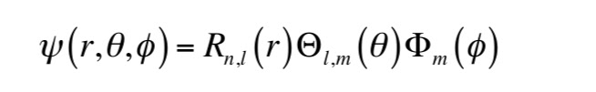

On solving Schrodinger equation for H atom by variable. We obtain three different Quantum number

1. Principle quantum number(n)- account for energy of and electron
2. Azimuthal quantum number(l)- total angular momentum of electron
3. Magnetic quantum number(m)-Z component of angular momentum

Wave function for HYDROGEN ATOM consist Angular and Radial part

Radial part is given by

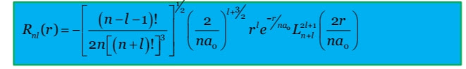

Total number of radial nodes is given by = **n-l-1**

Correct definition of an orbital is "orbitals are the acceptable wave function of an electron for a given set of n, l &m which are solutions of Schrodinger’s equation.  
There are two types of nodes: radial nodes (spherical nodes) & angular nodes (nodal planes). By making 3d plot of solutions we come to know the shape of orbitals and their probability density by plotting radial probability